Activity I: Bringing More Context into Data Visualizations

(25 - 30 minutes)

- Goal: This exercise is intended to provide practice thinking about visualizing data with context to help bring understanding about disparities and facilitate decision-making.

Scenario
The county council liked your prioritization matrix work! Based on this, the council wants to take action that will make an impact at the system level. They are pushing for decreasing opioid prescription rates.
The council is now asking you to make a case for your rural county to address its particularly high need for decreasing this rate. You don’t have official data since COVID started, so the best you will be able to do is use historical data.
Your task includes finding the rural county with the highest rate (for today this highest rate county is ‘your task force’s county’). In addition, you should find the data that helps bring context to your findings and helps inform decision-making.

Part 1 of the Activity (20 - 25 minutes)
Go to the SHARE-NW opioid data dashboard we were viewing during the training. The dashboard where this can be found is under the “Drug Use” tab (1) within the “Retail Opioid prescriptions” (2) indicator here:

- https://sharenw.nwcphp.org/dashboards/mental-behavioral-health
When you are on the dashboard, under the “State” selector (3), check only “Washington,” under the “Rurality” selector (4) check only “Rural,” and select the “Multi-year” view (5) on the right side of the dashboard. This will give you a line chart with rural Washington state counties that should look like this:
4
3
1
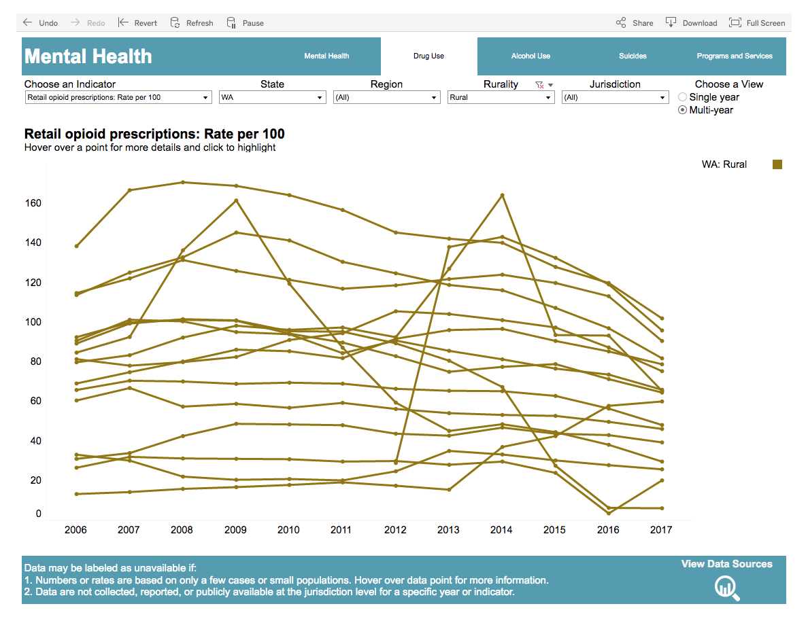
5
2
Individually review this dashboard to find the county with the highest rate in the most recent year that also appears to have a consistently high rate over time. Now figure out what comparisons to make and what other data/information you might want to find to provide context to the county with the highest rate.
Potential comparisons:
- rate for a county that has been consistently low over time that might be demographically similar (e.g., also rural)
- rate for county that used to have high rates but over time the rates got low

Part 2 of the Activity (5 minutes)
Respond to two (2) of the following prompts below with a short, two-sentence summary of your discussion.
- What comparisons did you choose and why?
- What do these prescription rate data & comparisons tell you about health disparities? And what don’t they tell you?
- What other information or context do you need to bring more understanding about opioid prescription rates, opioid deaths, and related health disparities in order to support decision-making as a task force?
Record your response below. Prepare to share it with the larger group.

Activity II: Make an Infographic (30 – 35 minutes)

Goal: Use the data from the retail opioid prescriptions dashboard to make an infographic.

Scenario
Your task force is tasked with presenting an infographic to convey the opioid prescription data from Activity I to policymakers and the public in order to support their decision-making around opioid policies/funding and behaviors, respectively, to address opioid death rates in the Washington county you identified as having the consistently highest opioid prescription rate.

Part 1 of the Activity (15 – 20 minutes)
The facilitator will assign each team member to design an infographic for either (1) policymakers or (2) the public.

Next, on your own, each group member takes a piece of paper and sketches an infographic using the opioid prescription rate data you reviewed in Activity I. Make note of the decisions you made for your designs, considering the following:

- Who is your audience?
- What decisions will they be making with the data presented in the infographic?
- What do you want them to do with the infographic?
  - Based on this, what tone or motivation do you want to try to instill?

Part 2 of the Activity (10 minutes)

Share your infographic with the group and discuss what influenced your design decisions. As a group, think about what visual elements across the designs:

- Help provide a clear understanding of the data?
- Helps someone make decisions or compels them to act?

Part 3 of the Activity (5 minutes)
As a group, record 1-2 takeaways you got from this activity about the following:
- What did you learn about the process of understanding data?
- What did you learn about making decisions about representing data in a way that supports understanding and action?

