1995 Chicago Heat Wave Scenario

This scenario is drawn, in large part, from Eric Klinenberg’s book, Heat Wave, in turn drawn in large part from research he carried out for his doctoral work in sociology at the University of Chicago in 1995

On Wednesday, July 12, 1995, the Chicago Sun-Times ran a story on page three stating, “Heat Wave on the Way, and It Can Be a Killer”. The temperature was 95F on that afternoon, and was over 100F for the next several days. The story predicted the Heat Index to be 120 for the next few days, as well.

Thursday, July 13, 1995, temp 106, heat index 126. Brick houses and apartment buildings baked, and temperatures in high rise building reached over 120F, even with the windows open. Newspapers and TV meteorologists urged people to “use air conditioners drink plenty of water and relax”. Thousand of cars broke down on the streets. One hundred thousand people jammed the beaches. Hundreds of small children riding school buses stuck in downtown traffic developed heat exhaustion. Adults carried them out of the buses, and firefighters hosed them down. Some were hospitalized.

Friday, July 14, 1995 temp over 100F. The heat index was over 100 for the third consecutive day, with temperatures remaining in the 80’s at night. Three power transformers failed, leaving 49,000 people without lights, air conditioning, radio, TV, or elevators. 3,000 fire hydrants were opened, resulting in a drop in neighborhood water pressure. Firefighters were sometimes stoned when they tried to shut off the hydrants. Calls to 911 increased, overwhelming available ambulances. For 3900 calls, no 911 vehicles were available. Fire trucks were dispatched to answer calls, but response time increased from 7 minutes to over 30 minutes in some instances. Firefighters and police had to carry elderly sick persons down the stairs when the elevators stopped working. Emergency departments were overwhelmed, forcing 20 of the 38 city hospitals to close their emergency rooms (go on “bypass” status). Ambulances and fire trucks could not find out about the bypass status and continued to arrive, resulting in additional confusion at many hospitals in the south-side of Chicago.

Many heat victims were not discovered or taken to hospitals in time for help. The city medical examiner’s office normally saw 14 bodies per day, On Thursday, they saw 82 bodies. As bodies were brought in, the 14 pathologists worked quickly, but they could not keep up. A nearby meat packing company lent 18 refrigerator trucks to preserve the bodies until they could be properly examined. The citywide norm for July deaths was 76 deaths per day. Since the body can withstand such high temperatures for only 48 hours without relief, the death toll rose sharply after Thursday. On Friday, July 14, 1995 188 Chicago residents were reported dead. The mortality on Saturday was 365, five times the normal number. The mortality for Sunday was 245, Monday193, and Tuesday 106, Wednesday, 92 and Thursday 91.

The medical examiner was from a politically active Chicago family and realized that he needed to have a good definition for a heat related death to defend his findings.

His definition for a heat related death was one of the following:

- A person with an internal body temperature of 105F at the time of death or just after
- Substantial environmental or circumstantial evidence of heat as a contributor to death (e.g. decedent found in a room without air conditioning, all windows closed, and a high ambient temperature)
- Decedent found in a decomposed condition without evidence of other cause of death who was last seen alive during the heat wave period

Question: In the aftermath of this disaster, who was at risk for sharing blame for what didn’t go right?

What do the following graphs and tables show?

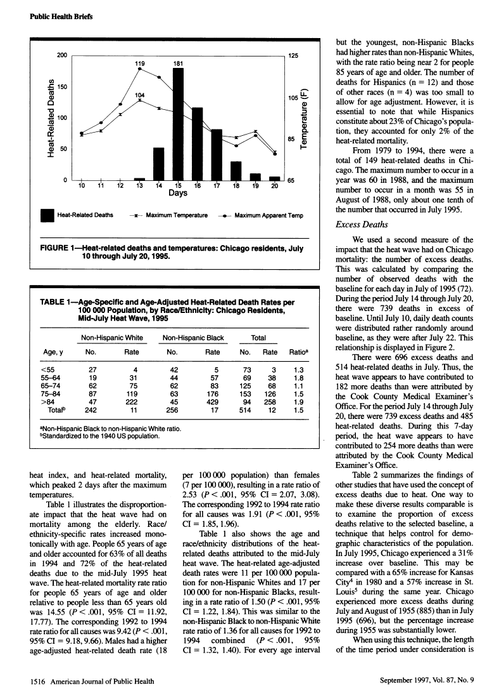

During the heat wave and in hindsight, it was noted that many of the dead were elderly and living alone. They died behind locked doors with their windows closed. At the end of the month, 170 bodies were unclaimed, despite investigators efforts to locate next of kin, family and friends.

Age specific or age stratified death rates and standardized death rates show that African Americans had 1.5 to 2.0 times the death rate of whites, even though the numbers of deaths were the same in each age stratum.

Now the case gets interesting. Mayor Daley appointed a task force to study the “epidemiological, meteorological, and sociological aspects of the heat wave”. The Commission’s report began with the statement, “The heat wave was a unique meteorological event”. Klinenberg states that this report buried the city’s failures.

What do you think he meant by that statement? Specifically, who failed?

Mayor – Remembered how a previously Mayor Jane Byrne had been elected, in part, because a previous mayor had failed to handle snow removal. His first reaction was to deny the accuracy of M.E,’s figures
Department Heads Said that responsibility was outside their control (i.e. due to failure of power companies and media)
Health Department – Not enough outreach personnel
Hospitals – Didn’t have emergency plans, and ways to communicate to outside emergency services
Fire Fighters – Didn’t implement their own emergency plans to call in more help
EMT’s – Didn’t have communication plans with hospitals
Community Agencies (Churches, Block Clubs) - Didn’t have close enough contact with elderly people living alone – felt that the City should have done more
Community Activists – Should have known whom the most vulnerable were, and provided for them
General Public – Should have taken better care of their family members
Media – Didn’t do enough to get the word out

Questions: How did epidemiology contribute to providing accurate data as to what actually happened?
What epidemiology concepts would have helped to improve communications as to what was going on?
Klinenberg statement: “…There is no simple explanation for why so many Chicagoans died in the trauma, and there is certainly no individual or group responsible for the crisis…when hundreds of people die slowly, alone, and at home, unprotected by friends and family and assisted by the state, it is a sign of social breakdown, in which communities, neighborhoods, networks, governmental agencies, and the media charged with signaling warnings are all implicated.” p.32

References

Klinenberg, Eric. Heat Wave: A Social Autopsy of Disaster in Chicago. 2002. The University of Chicago Press. Chicago and London.

Whitman S, Good G, Donoghue ER, Benbow N, Shou W, Shanxuan M. Mortality in Chicago attributed to the July 1995 heat wave. Amer J Pub Hlth 1997 87(9):1515-1518

Semenza JC, McCullough JE, Flanders D, McGeehin MA, Lumpkin JR. Excess Hospital admissions during the July 1995 heat wave in Chicago. Am J Prev Med 1999:16(4)269-277
Instructor’s notes:

- Mention importance of having a good case definition
- Politically not acceptable to have a high number of deaths during the heat wave (suggests City might have done more before or during the heat wave)
- Plot cases by person place and time
- Concept of excess deaths or hospitalizations
- These were not people who were ready to die, and the heat was the last insult to bring about their death
- Go over graphs and tables
  - Excess deaths
  - Table 1. Rate rises with age; rate higher for non-hispanic blacks at every age
  - What does standardized to the US 1940 population mean?
- Plot cases by place and time
- Surveillance or registry of vulnerable persons:
  - Elderly persons
  - Persons living alone
  - People on medication for chronic conditions
  - ? Other risk factors
- Q. p4 : How did epidemiology contribute to providing accurate data as to what actually happened? (definition of heat related death (was there any misclassification of cause of death, and did it matter?); concept of excess deaths; proving that these were people who were not ready to die)
- Q. p4 ? What epidemiology concepts would have helped to improve communications as to what was going on? (surveillance system during the heat wave: registry of older vulnerable population; targeting neighborhoods at risk)

